Being conformed - what is the believer’s part?

Romans 8:28-30 (NASU; all Scripture references are NASU unless stated otherwise)
And we know that God causes all things to work together for good to those who love God, to those who are called according to His purpose. 29 For those whom He foreknew, He also predestined to become conformed to the image of His Son, so that He would be the firstborn among many brethren; 30 and these whom He predestined, He also called; and these whom He called, He also justified; and these whom He justified, He also glorified.

In Romans 8:28-30 nearly all the statements about who we are were written from the perspective of God’s actions in the life of the believer, including His actions in the past, the present and the future. The only action that we take in these verses is a responsive action to His love for us, “those who love God”. Even in those words, it is essential that we understand that it was God who loved and gave first, and we would respond by loving God - and others:

John 3:16
"For God so loved the world, that He gave His only begotten Son, that whoever believes in Him shall not perish, but have eternal life. NASU

Galatians 2:20
"I have been crucified with Christ; and it is no longer I who live, but Christ lives in me; and the life which I now live in the flesh I live by faith in the Son of God, who loved me and gave Himself up for me. NASU

Ephesians 5:2
and walk in love, just as Christ also loved you and gave Himself up for us, an offering and a sacrifice to God as a fragrant aroma.

Ephesians 5:25
Husbands, love your wives, just as Christ also loved the church and gave Himself up for her,

1 John 4:19
We love, because He first loved us.

So does that mean that being conformed to the image of Christ is entirely a sovereign process, in which we have no part whatsoever? No. What it means is that while we are ultimately predestined to be conformed to the image of Jesus Christ, all of our responses to God causing all things to work together for good are addressed in other passages of Scripture. As we said last week, God is working in each of our lives in so many ways that our study of our part in the process will just scratch the surface, but it is still very well worth our while. So let’s begin…
Being conformed by God’s working in the physical & spiritual realms
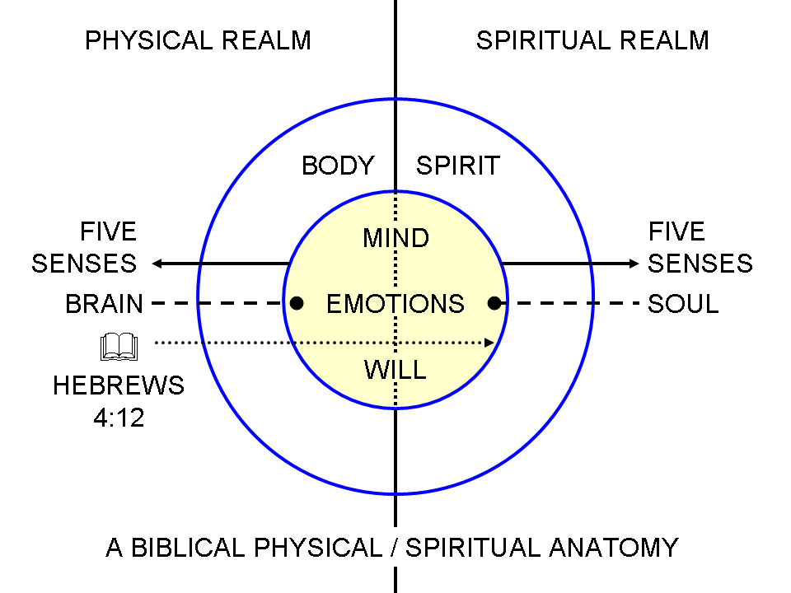
The point we’ve continued to make is that God made human beings to be both physical beings and spiritual beings. God causes all things to work together – and some translations have it that God works all things together for good – to the predestined end that the believer’s Continuing Person is conformed to the image of Jesus Christ, the Son of God.

The believer’s will

And in the ‘all things’ in which God works, that are both physical and spiritual, there are a number of ways in which we are called to respond to the working of God. Whenever we see an imperative directed to the believer in the New Testament, as directed to the church under grace, there is an opportunity to respond cooperatively with God’s working in and through the ‘all things’. Along with the imperatives, which are an appeal to the will of the believer, there are also appeals to the will of the believer in the form of “I urge you’, ‘I exhort you’, etc. These appeals to the will of the believer are not simply an exhortation to make a choice of some kind, but are always appeals to choose in one direction: consistent with the New Man, the New Nature, and the revealed will of God. The believer’s will does not act in a vacuum or independently, but rather acts in connection with the use of senses (physical and spiritual), the mind (physical and spiritual), and emotions (physical and spiritual). The actions coming from that willing are carried out in the physical realm and in the spiritual realm. See also the short paper, “The Will of the Believer” on the “Materials” section of the HHBC website: http://www.hollyhillsbiblechurch.org/materials/the-will-of-the-believer/.

The ultimate issue of choice

While we make many choices every day, involving and impacting both the physical and the spiritual realm, the ultimate issue of choice for the believer is that of walking in the Spirit or walking in accordance with the Sin Nature. The nature of this walk is that God works ‘all things’ together for good to conform us to the image of His Son. That active process toward conformity is engaged and in progress in us as we walk in the Spirit, and is disengaged and not in progress in us as we walk in accordance with the Sin Nature.
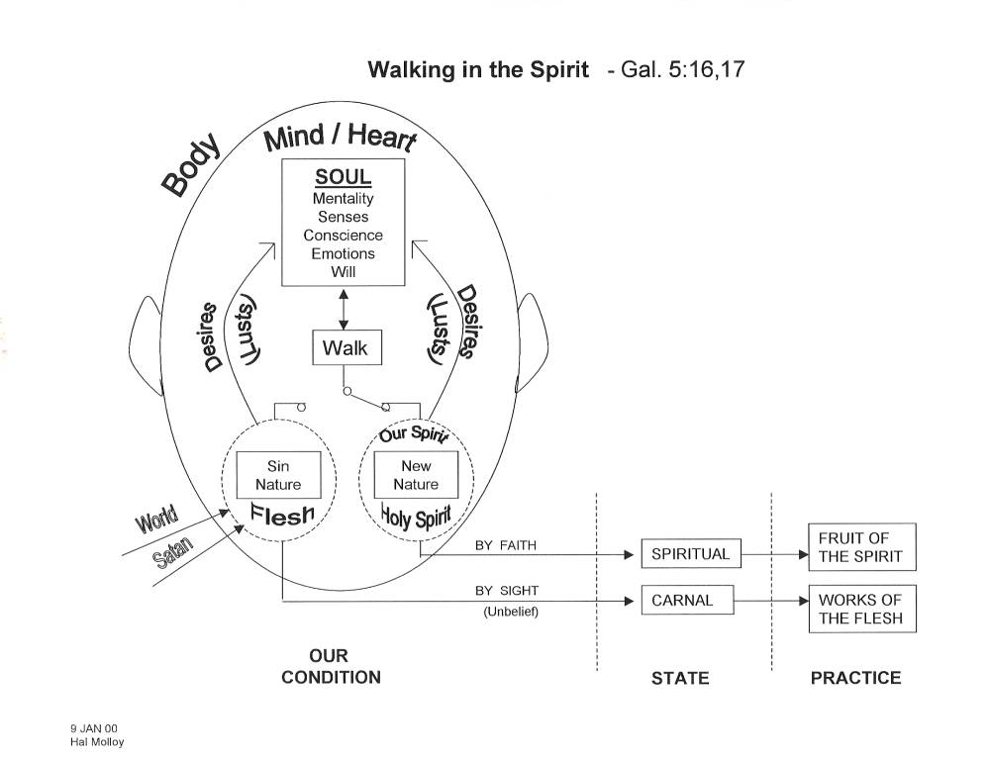

Trials & suffering - or discipline

Holly Hills presented an elective in 2004 that was entitled, “Trials & Suffering” (http://www.hollyhillsbiblechurch.org/messages/?series_id=47&series_page=40). While we will not even attempt to go into such detail here, it is important for us to express that God uses trials and suffering in the life of the believer to conform the believer to the image of Christ. And there is a part for the believer in the outcome of those trails and sufferings toward conformity:

1 Peter 4:12-19
Beloved, do not be surprised at the fiery ordeal among you, which comes upon you for your testing, as though some strange thing were happening to you; 13 but to the degree that you share the sufferings of Christ, keep on rejoicing, so that also at the revelation of His glory you may rejoice with exultation. 14 If you are reviled for the name of Christ, you are blessed, because the Spirit of glory and of God rests on you. 15 Make sure that none of you suffers as a murderer, or thief, or evildoer, or a troublesome meddler; 16 but if anyone suffers as a Christian, he is not to be ashamed, but is to glorify God in this name. 17 For it is time for judgment to begin with the household of God; and if it begins with us first, what will be the outcome for those who do not obey the gospel of God? 18 And if it is with difficulty that the righteous is saved, what will become of the godless man and the sinner? 19 Therefore, those also who suffer according to the will of God shall entrust their souls to a faithful Creator in doing what is right.
James 1:2-4, 12-13
Consider it all joy, my brethren, when you encounter various trials, 3 knowing that the testing of your faith produces endurance. 4 And let endurance have its perfect result, so that you may be perfect and complete, lacking in nothing… 12 Blessed is a man who perseveres under trial; for once he has been approved, he will receive the crown of life which the Lord has promised to those who love Him.

So, according to the passages above what mindsets and actions is the believer to take as they encounter trials and suffering?

But there may in fact be another reason for difficulties, aside from the trials and suffering aimed towards our conformity to the image of Christ, and our biblical response in those trials: discipline. A believer who is not walking with the Lord, and not living accordingly is likely to be judged and disciplined by the Lord Himself:

Hebrews 12:4-13

You have not yet resisted to the point of shedding blood in your striving against sin; 5 and you have forgotten the exhortation which is addressed to you as sons,

"My son, do not regard lightly the discipline of the Lord, nor faint when you are reproved by him; 6 for those whom the Lord loves he disciplines, and he scourges every son whom he receives."

7 It is for discipline that you endure; God deals with you as with sons; for what son is there whom his father does not discipline? 8 But if you are without discipline, of which all have become partakers, then you are illegitimate children and not sons. 9 Furthermore, we had earthly fathers to discipline us, and we respected them; shall we not much rather be subject to the Father of spirits, and live? 10 For they disciplined us for a short time as seemed best to them, but He disciplines us for our good, so that we may share His holiness. 11 All discipline for the moment seems not to be joyful, but sorrowful; yet to those who have been trained by it, afterwards it yields the peaceful fruit of righteousness.

12 Therefore, strengthen the hands that are weak and the knees that are feeble, 13 and make straight paths for your feet, so that the limb which is lame may not be put out of joint, but rather be healed.

Now unlike the people of Israel, the Church is never the recipient of God’s wrath, and is in fact promised never to be subject to God’s wrath. But God can and does discipline believers to the end that they will return to a path of fellowship with Him and with one another.
The ministries of the Holy Spirit

In our last lesson we listed the ministries of the Holy Spirit, as first generated by Hal Molloy. Though we will not relist those ministries here, we would do well to explore which of those ministries are such that we have a part in responding to them or living harmoniously with the ministry of the Holy Spirit. Certainly, an imperative to walk by means of the Spirit is a clear instance of our responding to and cooperating with the work that God has done and is doing in our lives (Galatians 5:16, 25).

Just a reminder: the word ‘let’ is used here an elsewhere in the Bible in the sense of an imperative – something we must do or not do, when used with a negative. The word ‘let’ does not mean to simply ‘allow’ in the New Testament, from Acts to Revelation.

