Conformed & Transformed

Romans 8:28-30 (NASU; all references are NASU unless stated otherwise)
And we know that God causes all things to work together for good to those who love God, to those who are called according to His purpose. 29 For those whom He foreknew, He also predestined to become conformed to the image of His Son, so that He would be the firstborn among many brethren; 30 and these whom He predestined, He also called; and these whom He called, He also justified; and these whom He justified, He also glorified.

Romans 12:1-2
Therefore I urge you, brethren, by the mercies of God, to present your bodies a living and holy sacrifice, acceptable to God, which is your spiritual service of worship. 2 And do not be conformed to this world, but be transformed by the renewing of your mind, so that you may prove what the will of God is, that which is good and acceptable and perfect.

2 Corinthians 3:17-18
Now the Lord is the Spirit, and where the Spirit of the Lord is, there is liberty. 18 But we all, with unveiled face, beholding as in a mirror the glory of the Lord, are being transformed into the same image from glory to glory, just as from the Lord, the Spirit.

The words translated ‘conformed’ and ‘transformed’ in the Greek New Testament are used rather rarely. And, the two words are not used as synonyms, but rather in contrast to one another, as in Romans 12:1-2. Next month we will focus on the word ‘transformed’:

Mar No. Passage / Topic

6 10 Being transformed – what is that process?
13 11 Being transformed – what is God doing?
20 12 Being transformed – what is the believer’s part?
27 13 Being transformed – not conformed to this world

But for today we will see how the two words are defined and contrasted, and how believers are warned not to be conformed to this world (Romans 12:1-2).

This world

The Bible, particularly in the New Testament, uses the term ‘world’, as a satanically dominated and governed world system. One of the passages that conveys this use of the term ‘world’ is Ephesians 2:1-3:

Ephesians 2:1-3
And you were dead in your trespasses and sins, 2 in which you formerly walked according to the course of this world, according to the prince of the power of the air, of the spirit that is now working in the sons of disobedience. 3 Among them we too all formerly lived in the lusts of our flesh, indulging the desires of the flesh and of the mind, and were by nature children of wrath, even as the rest.
The words, “And you were dead in your trespasses and sins, 2 in which you formerly walked…” refers to the individual position and walk of unbelievers. Unbelievers are positionally in their trespasses and sins, and they personally own and possess their sins (John 8:24; 1 Corinthians 15:17). The walking (an Old Testament and Jewish term) is the individual ordering of ones life and steps, having a spiritual basis and consequence. Then Paul writes, “according to the course of this world, according to the prince of the power of the air”. Now ‘according’ means ‘consistent with’. The unbeliever’s walk is ‘consistent with’ the course of this world (the present world system) and the prince of the power of the air – Satan. Satan works in the sons of disobedience. You may recall that the biblical use of the word ‘son’, when it does not mean a literal biological and genealogical son, means, ‘like in character and close in relationship’. ‘Formerly’ is consistently used by the New Testament authors to refer to our life and identity before we were saved.

As unbelievers, we lived right in among the rest of the unbelievers in this position, walk, and spiritual domain – the world. The word for ‘lived’ conveys interactive living among and between others, as opposed to the individual ‘walk’. The lusts of the flesh (the sin nature as expressed through the human body), indulging the desires and passions of that flesh and of the active mind of the fallen person. Right alongside the other unbelievers, when we were not yet saved, we were by nature, “…like in character and close in relationship’ to those unbelievers, who are and will be under God’s wrath (Ephesians 5:6).

Not conformed to this world

The reason for taking the time to bring clarity to the biblical meaning of the term ‘world’ is so that we have clarity when Paul warns us as believers not to be conformed to this world. Between Romans 8:28-30 and Romans 12:1-2 we gain several valuable insights into biblical conformity:

- God has predestined us who believe to be conformed to the image of His Son – that ultimate conformity to the image of His Son will not be thwarted.
- There is an alternate conforming in the near term that is not to the image of the Son, but to the world. The world has a form to which it is powerfully prone to conform us.
- Though God has predestined that we be conformed to the image of His Son in the ultimate, in the near term whether we are conformed to this world or conformed to the image of God’s Son is based on a decision that we are urged to make moment by moment. Sin Nature dependence and abiding is consistent with conformity to the satanic world system.
- Similar to being dead to sin but alive to God, we are not just called to simply resist being conformed to this world. We are called to an alternate and by nature different conformity: transforming by the renewing of your mind.
- By examining the spiritual entities involved in the conformity to this world (the world, the flesh and the devil), we find that believers, through their identification with Christ, have been spiritually separated from the world (Galatians 6:14; Colossians 2:20) which is the domain of Satan, and separated from the flesh (the Sin Nature as it operates through this body; Romans 6:1-14).
Transformed by the renewing of your mind

It is indeed curious that Paul does not write, “And do not be conformed to this world, but be conformed to the image of His Son.” We might expect him to say that, having already said that there is a conforming process aimed toward the conformity to Christ that is predestined (Romans 8:28-30). But instead Paul prescribes a different means for avoiding the conformity to this world, which is God’s intended alternate.

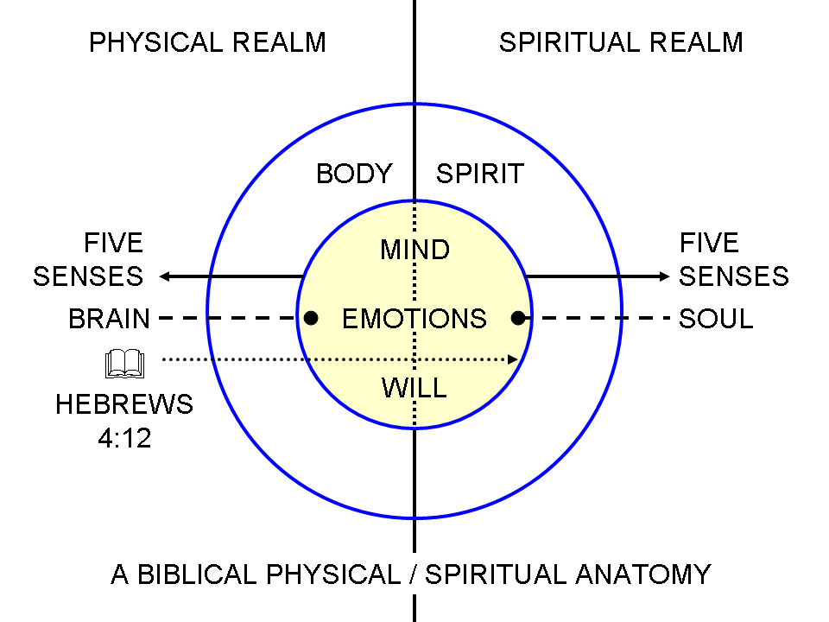
Being “transformed by the renewing of your mind” fits with the diagram we have been using to guide our understanding. What is being renewed is not primarily our physical side mind – our brain – but rather the spiritual side of the mind, which is in the soul, on the spiritual side of person who is a believer. Now we are going to examine what it means to be transformed in more detail for the next several weeks (during the month of March). But for now we have seen that there is a godly conforming process and an ungodly conforming process. But there is only a godly transforming process – the world offers noting like it. And we see from Romans 12:2 that the god-intended transformation process takes place though the renewing of your mind.

Ephesians 4:20-24 (NASU with some retranslation in expanded & explained format)
But you did not learn Christ in this way, 21 if indeed, which is assumed to be true for the sake of logic, you have actively heard Him and have received the teaching in Him, just as truth is in the Jesus, 22 that, in reference to your former manner of life, you have laid aside the old self – all of who you were in Adam, which [in unbelievers] is being corrupted in accordance with the lusts of deceit, 23 and that you be renewed in the spiritual aspect of your mind, 24 and have already put on the new self – all of who you are in Christ, which in the likeness [synonymous with ‘image’] of God [as expressed in the person of Christ], has been created in righteousness and holiness of the truth.

Titus 3:4-7 (NASU with some retranslation in expanded & explained format)
But when the kindness of God our Savior and His love for mankind appeared, 5 He saved us, not on the basis of deeds which we have done in righteousness, but according to His mercy, by the washing of regeneration and renewing by the Holy Spirit, 6 whom He poured out upon us richly through Jesus Christ our Savior, 7 so that being justified by His grace we would be made heirs according to the hope of eternal life.

Renewing is positional, at the time we were saved by faith in Christ, as a work of the Holy Spirit (Titus 3:5), and renewing is also an ongoing process which centers in the spiritual aspect of the believer’s mind, in which the Holy Spirit also carries on an ongoing ministry. We will explore the meaning of this more in our study of what it means to be transformed during the month of March, but meanwhile we will put it this way:

Being transformed is a miraculous process within us, carried out by the Holy Spirit, in which we are changed from glory to glory – increasing in the glory of the Lord – which is centered upon beholding the Living Word through God’s written word, the Bible. This transforming ministry of the Holy Spirit, using the written word of God, touches us in the deepest part of our being, to the end that we are increasingly made into the image of God’s Son. The mind, which was once actively indulged for the sake of the flesh, is now being progressively renewed in our condition, being made fit for godly purposes and the sharing of His glory – the radiant essence of who God is. Our mind, in this process, is ever more filled with and occupied by Him.

As God conforms us to the image of His Son, the miracle is that God works all things together for that good end and purpose. As God, through the Holy Spirit, transforms us into the image of His Son, the miracle is the Holy Spirit’s supernatural work within us, using His written word which is also a work of the Holy Spirit.

