Being transformed – what is that process?

Romans 12:1-2 (NASU; all Scripture quotes are NASU unless stated otherwise)
Therefore I urge you, brethren, by the mercies of God, to present your bodies a living and holy sacrifice, acceptable to God, which is your spiritual service of worship. 2 And do not be conformed to this world, but be transformed by the renewing of your mind, so that you may prove what the will of God is, that which is good and acceptable and perfect.

2 Corinthians 3:17-18
Now the Lord is the Spirit, and where the Spirit of the Lord is, there is liberty. 18 But we all, with unveiled face, beholding as in a mirror the glory of the Lord, are being transformed into the same image from glory to glory, just as from the Lord, the Spirit.

We’ve been talking about being ‘conformed’ during the month of February, introducing the word ‘transformed’ just last Sunday, February 28th. Interestingly, the above two passages are the only ones in all of the New Testament epistles that use the word ‘transformed’. There are, however, two passages in the Gospels that speak of Christ being transformed.

Matthew 17:1-2 (see also Mark 9:2-3, which describes the very same event similarly)
Six days later Jesus took with Him Peter and James and John his brother, and led them up on a high mountain by themselves. 2 And He was transfigured before them; and His face shone like the sun, and His garments became as white as light.

The Greek word that is translated as ‘transfigured’ is the same word as is translated ‘transformed’ in Romans 12:2 and 2 Corinthians 3:18. There was a change in Christ’s appearance which further revealed and made apparent His essential glory (the radiant essence of who He is), but did not change who He fundamentally was – His basic identity remained the same. His deity, however, was gloriously revealed.
The transformation of the believer has some points of comparison with Christ’s transformation as described in the Gospels of Matthew and Mark. In each case:

- God is the one who does the transforming, and Christ or the believer is the one who is on the receiving end of that transforming process.
- The transforming process is miraculous – it is not a natural process originating from the physical realm. It is a miraculous process originating from the spiritual realm.
- The transforming process is based on and is centered in truth and reality, as opposed to deception or even mistaken perception.

But while there are certainly points of comparison between how Christ was transformed and how the Christian believer is transformed, there are also important differences. Those differences include:

- Christ’s change as He was transformed amounted to a glorious revealing of who He was and is as deity – it was a change that revealed His essential glory. Also, Christ never came from a place of being saved from sin, so His essential glory was not changing, only its appearance. Christ was who He was.

- We, on the other hand, are transformed from glory to glory (2 Corinthians 3:18), that is, there is a change of and increase in glory. As we are changed - transformed – God brings about miraculously an increase in glory which is from the Lord Himself, as He shares His glory with us. And while Christ was always who He was when He was transformed, we are increasing in glory, in our Continuing Person, which is changing in the direction of and toward who Christ is.

Conformed and transformed – how do these compare?

We have described being conformed as God working all things together for good, both physical and spiritual, to the end that we are conformed into the image of God’s Son, Jesus Christ. We compared this spiritual conforming process to the physical conforming process of slowly tapping a flat piece of sheet metal into another shape. We gave the example of the flat piece of sheet metal being tapped one stroke at a time into a convex form in order to make a protective hand-hold on a Roman shield.

But being transformed, though it has the same end result, which we could summarize as ‘Christlikeness’, is accomplished also by God, but through an entirely different means and process. While we will explore that means and process further, that transforming takes place miraculously, and the word is used for the transforming of a butterfly egg to a caterpillar to cocoon to an adult butterfly. The change in form is profound, and is a change that takes place from information that God has built into each cell of the egg > caterpillar > cocoon > butterfly. As opposed to the conforming process, where we can see at least some of the things that God works together and uses to accomplish His conforming of us to the image of His Son, this transforming process is wondrous and miraculous and marvelous. The change takes place from God’s own work within us.


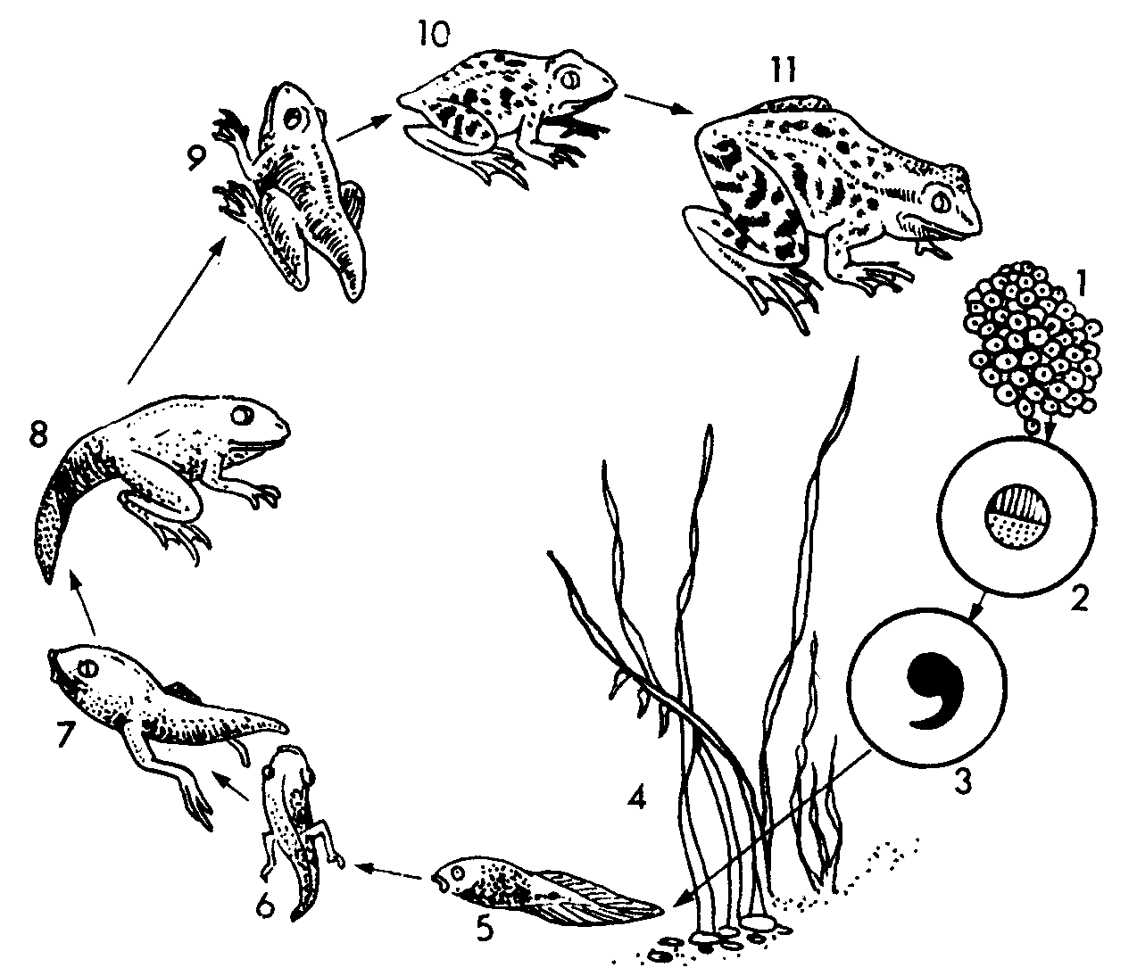

Taking a look at 2 Corinthians 3:17-18

Above are a couple of illustrations of metamorphosis in the biological realm (used by permission from: http://www.arthursclipart.org/biologya/biology/page_05.htm), which helps to illustrate the degree and kind of change involved in metamorphosis, as long as one does not apply the physical / biological change too rigidly to the spiritual change that is described in Romans 12:2 and 2 Corinthians 3:18. One principle in common between the biological metamorphosis and the spiritual metamorphosis is that while the radical change called metamorphosis takes place in an environment, the change takes place largely on the basis of internal direction and information rather than through the external circumstances. The great transformation that takes place does not appear to be driven from any externally identifiable causes.

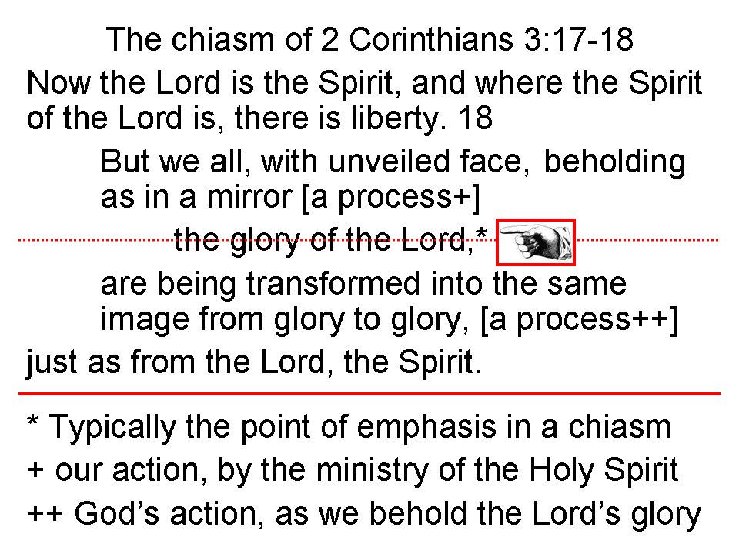
2 Corinthians 3:17-18 has the form of a chiasm, which is a mirror image in literary form. Verse 17 is referring to the Holy Spirit. The term, “the Spirit of the Lord” is found here for the last time in the Bible, but the exact same term is used 28 times in the Bible, starting with Judges 3:10. In each case, it refers to the Holy Spirit, the third person of the Trinity. We will explore the meaning of these words further next Sunday.

The word pair “we all” refers to all believers, as it also does in 1 Corinthians 10:17 and in James 3:2. And the “we all” is in contrast to the nation of Israel, who had been under the Law, who was not at liberty, and who were spiritually blinded and hardened by trying to live the Law of Moses out of their own strength and resources. “We all” are those from whom the veil has been removed and lifted, because by turning to the Lord we are in Christ and have liberty. Wearing a veil means still being under the Mosaic Law, and the veil over the heart is removed when a person turns to the Lord in faith. The believer’s beholding of the glory of the Lord is not enhanced by the Law – a veil. The Law in 2 Corinthians 3 always veils something, always preventing open beholding.

The four words, “…beholding as in a mirror…” are translated from just one Greek word.
This Greek word is the word for looking into a polished first surface mirror, and Corinthian mirrors were famous. That likely explains why both Paul’s letters to the Corinthians (see also 1 Corinthians 13:12) contained a reference to a mirror, but not even one other letter by him did. Jesus’ half-brother James wrote:

James 1:22-24
But prove yourselves doers of the word, and not merely hearers who delude themselves. 23 For if anyone is a hearer of the word and not a doer, he is like a man who looks at his natural face in a mirror+; 24 for once he has looked at himself and gone away, he has immediately forgotten what kind of person he was.

In the three passages in the New Testament that refer to a mirror, the mirror represents God’s written word, as is evident here in the book of James.

The glory of the Lord is the center of Paul’s chiasm (see prior page) – the center being typically the focal point of the chiasm. Glory is the radiant essence of who God is. All glory is derived from God, since He is the ultimate source of all glory. Glory is not a thing or a commodity, but instead glory is very personal, radiating from His own essence. Our Lord even prayed in the final hours of His earthly life that we would see His glory, which will be ultimately fulfilled when we see Him face to face:

John 17:26
"Father, I desire that they also, whom You have given Me, be with Me where I am, so that they may see My glory which You have given Me, for You loved Me before the foundation of the world."

This being transformed is an ongoing action which is the Holy Spirit’s work upon each one of us as we behold the Lord, the Living word through His written word. The words, “into the same image” refers to the image of the Lord Jesus Christ, similar to the words in Romans 8:29. The phrase, “from glory to glory” is Paul’s expression of increasing, from one level to another – increasing glory. Just a chapter earlier, Paul wrote:

2 Corinthians 2:15-16
“For we are a fragrance of Christ to God among those who are being saved and among those who are perishing; 16 to the one an aroma from death to death, to the other an aroma from life to life…”

Being transformed is from the ministries of the Holy Spirit, bringing the word of God to us, bringing us to the word of God, and bringing about the transforming process in each one of us. So putting these truths together, we have come to the place where we can expand and explain them (see the next page).

2 Corinthians 3:18 expanded and explained
But all of us who are in Christ, with a face that is not veiled by the Law, having died in relationship to the Law and living by God’s amazing grace, are right now continuing to behold as we read and hear the written word of God, seeing as one who looks into a mirror, the glory – the radiant essence of who Christ is – the glory that comes from Christ Himself, and we are in fact in the very the process of being changed and transformed into the same spiritual character, growing from one level of Christ’s glory to the next, and every part of this beholding and transformation is from the God-given ministries of the Holy Spirit.

2 Corinthians 11:14 says, “No wonder, for even Satan disguises [KJV: transforms] himself as an angel of light.” The KJV here uses the English word ‘transforms’, but it is important to note that the Greek word behind it (metaschematizō) is different from the Greek word translated ‘transformed’ in Romans 12:2 and 2 Corinthians 3:18 (metamorphoō) in two important ways: 1) the two words are different words in the Greek, and the word applying to Satan indicates a change so as to disguise and deceive, and 2) the one applying to Satan is in the middle voice – Satan disguises himself. The uses of the Greek word translated as ‘transformed’ that apply to Christ or to Christians (all quoted above) are all in the passive voice, that is, Christ while on earth, and believers while on earth, receive God’s action of being transformed, which is spiritually positive, and is based on and remains in the truth. Christ did not deceptively obscure His true identity as He was transformed by God, and neither do Christian believers as they are transformed by God. Satan, however, is intrinsically and fundamentally a deceiver, so that his ‘transformation’, if we are to call it that, is always for the purposes of deception, to disguise who and what he really is (John 8:44).

