Being transformed – what is God doing?

2 Corinthians 3:17-18 is the central passage for insight into our being transformed. And even though it might not be readily apparent at every point, God’s part in this is bolded, which means that most of the passage is God’s part.

2 Corinthians 3:17-18 (NASU; Scripture quotes from the NASU, unless stated otherwise)
Now the Lord is the Spirit, and where the Spirit of the Lord is, there is liberty. 18 But we all, with unveiled face, beholding as in a mirror the glory of the Lord, are being transformed into the same image from glory to glory, just as from the Lord, the Spirit.

The Law of Moses, which is good and holy and righteous, because of human inability, requires those who seek to follow it to focus upon themselves, to be earthly minded in doing so, motivated by the promise of earthly blessings and the threat of earthly punishments – possibly even the end of earthly existence. In contrast to the veil of the Law, which diminishes the ability to have spiritual sight and insight, the indwelling of the Holy Spirit, in which there is liberty (which is not the same as license), provides for us a spiritual opportunity. Because of the multiple ministries of the Holy Spirit, and because of our co-crucifixion with Christ, we have died in relationship to the Law of Moses (Romans 7:4-6; Galatians 2:19), having no obligation to the Law of Moses nor any principle of law, we have no veil in place (covering spiritual eyes or hearts) to prevent us from seeing and beholding the glory of the Lord (2 Corinthians 3:17-18). This is the opportunity we have as a work of the Holy Spirit (rather than our own works) – and it is liberating indeed:

- Grace as the motive – do because you are already blessed in the heavenly places in Christ (Ephesians 1:3; 4:32), but not in order to be blessed in earthly ways or to avoid the threatened earthly curses.
- Means to accomplish – by the Holy Spirit enabled, first to fully see, but enabled, empowered and energized to carry out the works that God has prepared beforehand.
- Spiritual opportunity – as a work of God, we have multiple spiritual opportunities that would simply not be available under the Law of Moses nor any principle of Law.

While we who are in the body of Christ have a wonderful spectrum of spiritual opportunities before us, 2 Corinthians 3:18 focuses on the specific spiritual opportunity that we have under gracious liberty: to behold the glory of the Lord Jesus Christ through His written word. While we will focus upon our part in that next week (“…we all, with open face beholding…”), the outcome of our beholding the Lord – the Living Word of God through the written word of God – is that we are spiritually transformed. This transformation is written in the passive voice, which means that we are on the receiving end of the action of transformation. We don’t cooperate in the action. We don’t contribute to the action. We don’t even co-sponsor the action of being transformed. God does it all, entirely of His own gracious accomplishment in us. It’s not about us – it’s about Him, and centrally, it is ever about the Lord Jesus Christ.

Knowing what the Holy Spirit has done, is doing, and will do

In order to bring us the written word of God, the Holy Spirit has accomplished a fourfold sequence, as outlined in the insert below:

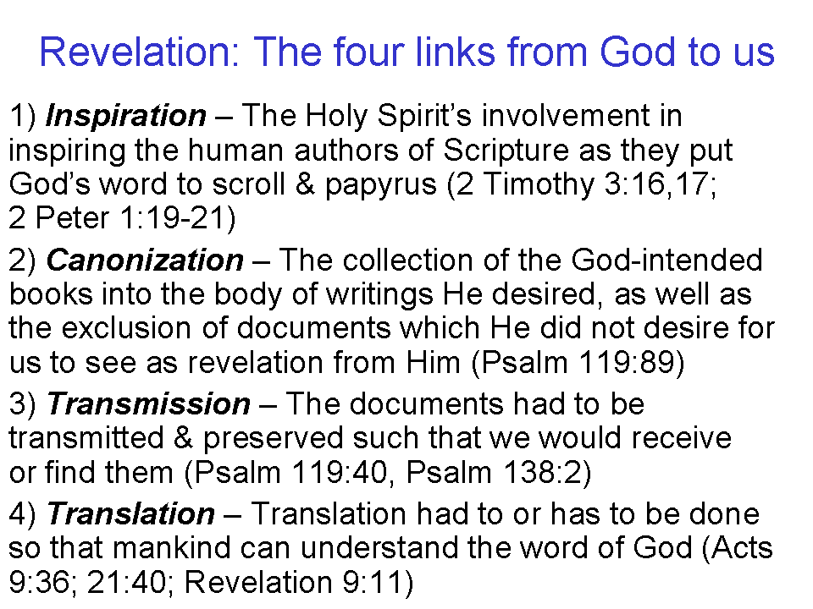
While most Christians will recognize that the first one of these – inspiration – is a work of the Holy Spirit, each ‘link in the chain’ is essential to our receiving revelation from God. Of the three persons of the Trinity, the Holy Spirit is the One who carries forward God’s revelation from inspiration of the Bible’s original authors to an understandable written and/or audible revelation (Ephesians 3:4; Colossians 4:16; Revelation 1:3).

So the Holy Spirit has brought us the written word of God - the mirror - so that we might read and / or hear it. While there is an active part that we play in the total fulfillment of what is conveyed in 2 Corinthians 3:18, and we will explore that further next Sunday, most of the verse describes the rest of what God does so that we are transformed.

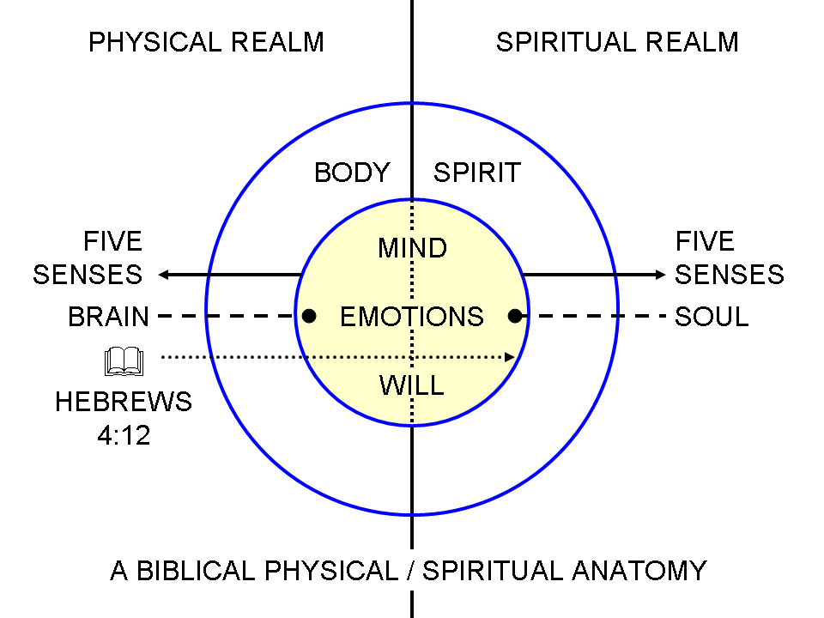
The glory of the Lord, which is the radiant essence of who God is, has two aspects in 2 Corinthians 3:18:

1) When we behold the Lord through His written word, it is not simply reading, as an intellectual exercise, all in the physical realm. Those who don’t believe can do that with no spiritual impact, and there are those among unbelievers who do exactly that. They may even be academically recognized for their physical side only expertise in the written words, and all of its earthly background. And there is a hazard that believers will do the same, keeping the word of God in their ‘gray matter’ but nowhere else. But the word of God is intended to reach the depths of us in the spiritual realm with penetration and impact (Hebrews 4:12). And the word of God is to be a critical instrument by which we are to have clear vision, hearing, etc. (full clarity and the full spectrum of sensation) into the spiritual realm (see diagram on prior page). And the glory of the Lord is not an impersonal commodity nor visible with the earthly senses, but it is personal to the Lord because the glory is from Him and is essential to who He is.

2) In addition to our beholding the personal glory of the Lord through the written word of God, as a result of the Lord sharing His glory with us, that shared glory increases from one level of glory to the next. That increasing glory is in contrast to the fading glory of the Law of Moses, the glory that must be veiled so that its decline might not be seen by others.

Who | What | People Group | Spiritual Visibility | Glory
Moses | Law | Israel, 'their' | veiled face & hearts | fading
Christ | Grace | ‘we all’, the church | unveiled, open face beholding | increasing

Do we begin to see a pattern here? We were not given the Holy Spirit to be present with us so that we could claim all of the characteristics of being under the Law. And we’ve got another dimension to examine in this contrast – was the glory from Moses’ face that was fading seen with physical eyes or spiritual eyes? Was the veil over Moses’ face made of physical material or spiritual material? Did the Law allow them to see more and better spiritually or to see less and worse spiritually? When someone turns to the Lord, what happens to the veil over their heart? If someone looks to the Law of Moses, is that person transformed as a result? Why or why not?

Connect the dots

John 16:13-15 (the Son & the Spirit)
"But when He, the Spirit of truth, comes, He will guide you into all the truth; for He will not speak on His own initiative, but whatever He hears, He will speak; and He will disclose to you what is to come. 14 He will glorify Me, for He will take of Mine and will disclose it to you. 15 All things that the Father has are Mine; therefore I said that He takes of Mine and will disclose it to you."

John 17:26 (the Son & the Father)
"Father, I desire that they also, whom You have given Me, be with Me where I am, so that they may see My glory which You have given Me, for You loved Me before the foundation of the world."

2 Corinthians 3:17-18 (the Son & the Spirit)
Now the Lord is the Spirit, and where the Spirit of the Lord is, there is liberty. 18 But we all, with unveiled face, beholding as in a mirror the glory of the Lord, are being transformed into the same image from glory to glory, just as from the Lord, the Spirit.
If we look at the above passages in sequence we see that our beholding the glory of the Lord Jesus Christ, as He has been and is glorified by the Father and the Spirit, is exactly what Christ told His disciples the Spirit would do, and what Christ prayed about to the Father, and what the Spirit carries out. So this beholding that 2 Corinthians 3:18 speaks of is from a deliberate cooperation and coordination between the Father and the Son and the Holy Spirit. The glory of the Son is the personal object of our beholding, and the Father is the one directing and orchestrating this gracious divine and personal process, the same One who has already blessed us in Christ in the heavenly places, and the Holy Spirit is the One who has brought about the means through which we behold the Lord Jesus Christ by bringing us the written word of God, by drawing us to behold the glory of the Lord Jesus Christ from the written word, and by carrying out the miraculous transformation process in our Continuing Person.

Examine how each of these passages in Hebrews ‘rhymes and harmonizes’ with 2 Corinthians 3:18, reinforcing what the word of God is uniquely capable of, and where we are called upon to place our spiritual focus and consideration:

Hebrews 3:1
Therefore, holy brethren, partakers of a heavenly calling, consider [katanoeō = kata + noeō: literally, against or to the mind, or as we might say, ‘apply your mind to it’] Jesus, the Apostle [special messenger] and High Priest [the one who is ultimately qualified to represent you before God] of our confession;

Hebrews 4:12
For the word of God is living and active and sharper than any two-edged sword, and piercing as far as the division of soul and spirit, of both joints and marrow, and able to judge the thoughts and intentions of the heart.

Hebrews 12:1-3
Therefore, since we have so great a cloud of witnesses surrounding us, let us also lay aside every encumbrance and the sin which so easily entangles us, and let us run with endurance the race that is set before us, 2 fixing our eyes on Jesus, the author and perfecter of faith, who for the joy set before Him endured the cross, despising the shame, and has sat down at the right hand of the throne of God. 3 For consider [analogizomai = ana + logitzomai; consider and count carefully] Him who has endured such hostility by sinners against Himself, so that you will not grow weary and lose heart.

The use of the word ‘mirror’ represents the written and ultimately the completed word of God in 1 Corinthians 13:12; 2 Corinthians 3:18; James 1:22-24.

