Being transformed – not conformed to this world

There are only two passages in the New Testament that speak of believers being transformed, these are quoted here, with emphasis by bold italics on the portions of these passages that will be our focus today:

Romans 12:1-2
Therefore I urge you, brethren, by the mercies of God, to present your bodies a living and holy sacrifice, acceptable to God, which is your spiritual service of worship. 2 And do not be conformed to this world, but be transformed by the renewing of your mind, so that you may prove what the will of God is, that which is good and acceptable and perfect.

2 Corinthians 3:17-18
Now the Lord is the Spirit, and where the Spirit of the Lord is, there is liberty. 18 But we all, with unveiled face, beholding as in a mirror the glory of the Lord, are being transformed into the same image from glory to glory, just as from the Lord, the Spirit.

We have explored what it means to be transformed as is described in 2 Corinthians 3:18, but we will turn now to the meaning of transformed in Romans 12:2. There are a few points we can make at the outset:

- Transformed in 2 Corinthians 3:18 is the same process as in Romans 12:2 – they are both referring to the same process, using the exact same Greek and English words, even though the words surrounding them differ. We will see shortly why and in what ways the surrounding words differ.

- The transforming process that 2 Corinthians 3:18 and Romans 12:2 refer to are the right spiritual alternate to being conformed to this world. Our focus ought not to simply be a refusal to be conformed to this world. Recognizing the conforming mold that this world system is inclined to press us into is good and well as far as it goes, but simply refusing to subject oneself to the worldly conforming process does not take us where we need to go. The proper biblical response is to be transformed by the means that 2 Corinthians 3:18 and Romans 12:2 prescribe and describe.

- In keeping with the ‘spiritual anatomy’ that we explored in this elective in January of this year, there are two points we will want to bring forward to the present discussion:

1) the part of the believer that is to be transformed is the Continuity of Person or Continuing Person – the spiritual part of the believer that continues from before he or she was saved by faith (see the first diagram on the next page).

2) as Romans 12:2 makes clear, being transformed involves the renewing of the mind, which in this case is referring to the spiritual mind (not just the gray matter – the physical part of the mind that is centered in the human brain), which is an aspect of the soul of the believer (see the second diagram on the next page).
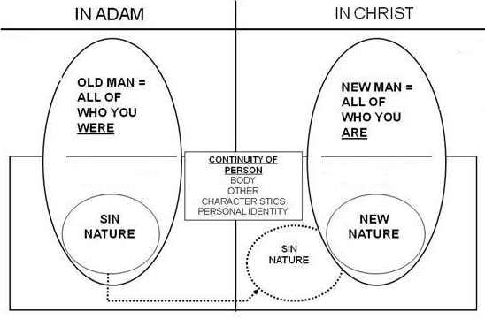
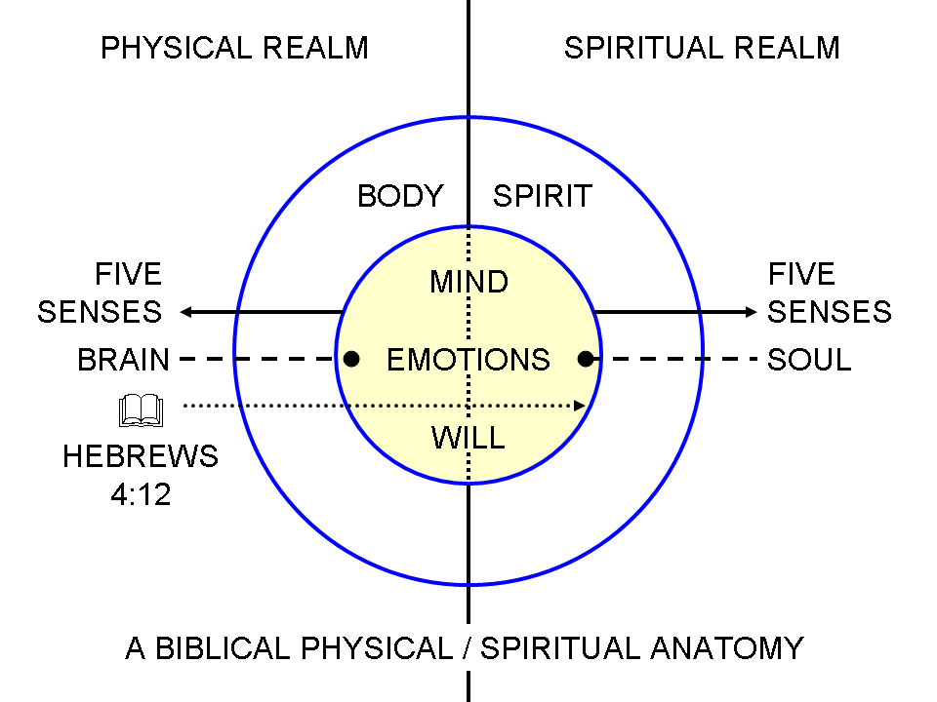

So what is ‘renewing of your mind’ and how does that connect with 2 Corinthians 3:18? We’re going to start by defining the terms ‘renewing’ and ‘mind’.

Renewing of your mind

In order to understand renewing of your mind, we have to start by what the New Testament says of the mind of unbeliever.

Romans 1:28
And just as they did not see fit to acknowledge God any longer, God gave them over to a depraved mind,

Ephesians 2:1-3
And you were dead in your trespasses and sins, 2 in which you formerly walked according to the course of this world, according to the prince of the power of the air, of the spirit that is now working in the sons of disobedience. 3 Among them we too all formerly lived in the lusts of our flesh, indulging the desires of the flesh and of the mind, and were by nature children of wrath, even as the rest.

Ephesians 4:17-18
So this I say, and affirm together with the Lord, that you walk no longer just as the Gentiles also walk, in the futility of their mind, 18 being darkened in their understanding, excluded from the life of God because of the ignorance that is in them, because of the hardness of their heart.

In the unbeliever, the character of the mind is consistent with the unbeliever’s position in Adam, having only the Old Self (Man) and the Old Nature, and as one who is lacking in spiritual senses, understanding, insight and discernment. Once a person comes to believe, however, there is in Christ a new position, New Man, New Nature, and new spiritual history. The spiritual senses have come alive, and there is the opportunity to truly renew the spiritual aspect of the mind, the part of the believer that is in the soul, but connected to and integrated with all of the other parts, both physically and spiritually. And it is critical to realize that the root of the Greek word translated as ‘renewed’ means new in kind. Being the New Creature in Christ, the spiritual mind of the believer can truly be renewed, constantly and progressively. As we said in our 2nd lesson in this elective:

Kenneth Wuest, on Ephesians 4:22 (page 111), “That you have put off once for all with reference to your former manner of life the old man which is being corrupted according to the passionate desires of deceit; moreover, that you are being constantly renewed with reference to the spirit of your mind that you have put on once for all the new man which after God was created in righteousness and holiness of truth.”

In the context of who you now are in Christ, your mind has some ‘catching up’ to do. So let’s see how this understanding allows us to connect 2 Corinthians 3:18 with Romans 12:2:

Ephesians 4:17-24 (NASU, expanded & explained)
So this I say, and affirm together with the Lord, that you walk, ordering your life step by step, no longer just as the Gentiles also walk, ordering their lives step by step in the spiritual and moral futility of their unredeemed mind, 18 being darkened in their understanding since they lack spiritual senses, excluded, that is, separated, from the life of God because of the ignorance that is in them, because of the hardness of their heart; 19 and they, having become callous (having no spiritual sensation), have given themselves over to sensuality for the practice of every kind of impurity with greediness. 20 But you have not actively learned from the Christ (the Messiah) as His disciple in this way, 21 if indeed you have actively heard Him and have been taught with a consistent message about having been placed in Him, just as truth is in the Jesus – and only Him, 22 that, in reference to your former manner of life, you have laid aside the old self, which is being corrupted in unbelievers consistent with the lusts of deceit, 23 and that you be new-in-kind renewed, in the spiritual aspect of your mind, 24 and having put on the new self, which in the likeness of God has been created in righteousness and holiness of the truth.

And then, in Titus 3:37 we read:

Titus 3:3-7 (NASU)
For we also once were foolish ourselves, disobedient, deceived, enslaved to various lusts and pleasures, spending our life in malice and envy, hateful, hating one another. 4 But when the kindness of God our Savior and His love for mankind appeared, 5 He saved us, not on the basis of deeds which we have done in righteousness, but according to His mercy, by the washing of regeneration and renewing by the Holy Spirit, 6 whom He poured out upon us richly through Jesus Christ our Savior, 7 so that being justified by His grace we would be made heirs according to the hope of eternal life.

So Ephesians 4:20-24 and Titus 3:3-7 are about learning the truth, not by mere intellectual ingestion, but by actively and personally learning the truth from Christ Himself, as His personal disciple. The renewing of the mind in the believer, which is centered in the truth, and is personal to Christ Himself, is a result of the ministries of the Holy Spirit. The spiritual renewal of the mind has the outcome that we are transformed. This is what it means to behold the glory of the Lord Jesus Christ through His written word, so as to be increasingly transformed into the image of Jesus Christ. Both the renewing and the transforming are the result of ministries of the Holy Spirit, and center our focus upon the person of Christ through the written word of God.

Ephesians 4:23 puts these words together as, “be renewed in the spirit of your mind”.

