Growing – what is the believer’s part?

Today we will want to examine what the believer’s part is in growth toward spiritual maturity. We can start by recognizing all of what God has done so that we can grow toward spiritual maturity – we explored that last week.

Faith, err… trust

One way to look at the believer’s part – and this is not just an optional perspective – is that the believer’s part in growth toward spiritual maturity is all summed up in faith (aka trust) in the biblically revealed facts. All of the believer’s part in growth toward spiritual maturity takes place in the context of what God has done, is doing, and will do. So as we learn, know and understand what God has done, is doing, and will do, and place our faith (aka trust) in Him for those things, we grow toward spiritual maturity.

To the extent that we do not learn, know and understand what God has done, is doing and will do (ignorance), we cannot place our faith in Him for those things, and we will not grow. To the extent that we learn, know and understand, but do not place our faith in Him for those things (self-dependence), we will not grow. To the extent that we try to do and take credit for what God has done or is God’s to do (works and legalism), we will not grow. Growth toward spiritual maturity only takes place when we see who we are in Christ and who He is in us and place our faith in Him accordingly.

Take it personally

Notice that God did not simply design an impersonal process or system, in which we simply follow a checklist or ‘push spiritual buttons’ or ‘flip spiritual switches’. And faith is more than just believing spiritual principles, as important as those may be. What God intends is that we have fellowship with Him based on the relationship He has established with us. Any of our learning or knowing or understanding or exercise of faith (aka trust) is personal. It is personal on our part and it is personal on God’s part. Growth toward spiritual maturity is not an impersonal system or machine process – it’s about the personal relationship with have with Him by grace, and the gracious fellowship we have because of the relationship!

God’s written word

God’s written word – the Bible – was inspired and preserved so that the believer might learn, know and understand. But it’s not just about data. Books and hard drives and other media can store data, but by itself there is no spiritual benefit. And even students can receive, and analyze and output data. But that’s not ultimately what God’s written word is for. God’s written word was personally inspired so as to be spiritually profitable and an essential instrument of growth toward spiritual maturity for every believer:

2 Timothy 2:15 (NASU; this and all Scripture quotes are NASU unless stated otherwise)
Be diligent [an imperative, calling for an act of will] to present yourself approved to God as a workman who does not need to be ashamed, accurately handling the word of truth. [see accompanying Roman roadway engineer and tentmakers overheads for key insights]
2 Timothy 3:16-17
All Scripture is inspired by God [literally, “God-breathed’] and profitable for teaching, for reproof, for correction, for training in righteousness; 17 so that the man [anthropos, not andros] of God may be adequate, equipped for every good work.

1 Peter 2:2
…like newborn babies, long for [an imperative, calling for an act of will] the pure milk of the word, so that by it you may grow in respect to salvation…

When we put it together, what these passages tell us is that these grace-motivated imperatives call for each one of us to diligently study and understand God’s inspired word so as to learn, and know and understand it, so that we can exercise faith in the revealed spiritual facts from God’s word. And that is why we meet together, and why we direct believers to the written word of God, not just for exposure to it, but for understanding it so that we may exercise faith in God for the purpose of fellowship with Him and for wise application to every aspect of this present life, and maximum preparation for when this present life is over.

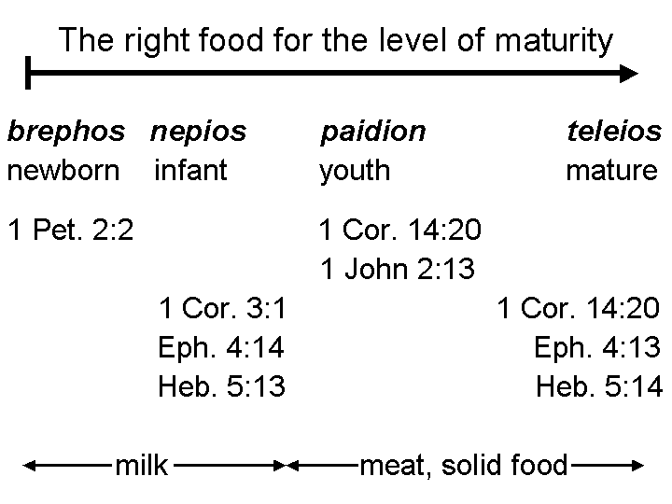
Individual believers, husbands and fathers, and leaders of church bodies ought to consider carefully the ages and stages of spiritual growth of each believer, and the food that corresponds to that growth, whether it is milk or solid food. There ought to be spiritual food appropriate for the age and stage of the believers under the care of husbands, fathers and church leaders – particularly church shepherds.

Through and through

We’re not talking about bullet holes here ☺. We’re talking about our course as we encounter various trials. While the natural human inclination when encountering trials is often to just look for the exit, the written word of God makes clear that our approach to the trials is what makes the difference in whether we come through the trials as approved, and having grown, which is what God intends, or whether we bypass the outcome God intends, with some other result and outcome. God intends that we go through the trial. The trial is God’s ‘prescription’ for the believer, and we are intended to ‘take the full course of the medicine as prescribed’.

James 1:2-8, 12-16

The approach to trials, character under the trial, & intended earth-time outcome:
Consider it all joy, my brethren, when you encounter various trials, 3 knowing that the testing of your faith produces endurance. 4 And let endurance have its perfect result, so that you may be perfect and complete, lacking in nothing.

The insight for ‘what if I need wisdom?’:
5 But if any of you lacks wisdom [assumed to be true], let him ask of God, who gives to all generously and without reproach, and it will be given to him. 6 But he must ask in faith without any doubting, for the one who doubts is like the surf of the sea, driven and tossed by the wind. 7 For that man ought not to expect that he will receive anything from the Lord, 8 being a double-minded man, unstable in all his ways…

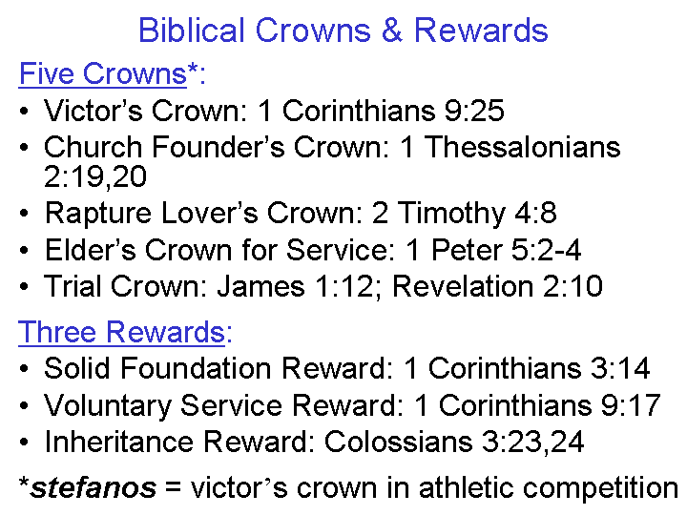
The positive path conveyed, & the intended heavenly reward:
12 Blessed is a man who perseveres under trial; for once he has been approved, he will receive the crown of life which the Lord has promised to those who love Him.

The negative warning portrayed:
13 Let no one say when he is tempted, "I am being tempted by God"; for God cannot be tempted by evil, and He Himself does not tempt anyone. 14 But each one is tempted when he is carried away and enticed by his own lust. 15 Then when lust has conceived, it gives birth to sin; and when sin is accomplished, it brings forth death. 16 Do not be deceived, my beloved brethren.

In case you need directions

The direction toward which our involvement with God’s word and the perseverance under trails is headed is growth in the person of Jesus Christ. Peter put it this way, even when he knew that his very last days were ahead of him:

2 Peter 1:2-3
Grace and peace be multiplied to you in the knowledge of God and of Jesus our Lord; 3 seeing that His divine power has granted to us everything pertaining to life and godliness, through the true knowledge of Him who called us by His own glory and excellence.

2 Peter 3:18
…but grow [an imperative, calling for an act of will] in the grace and knowledge of our Lord and Savior Jesus Christ. To Him be the glory, both now and to the day of eternity.

