Sanctified - conformed, transformed, maturing & growing

Position & condition

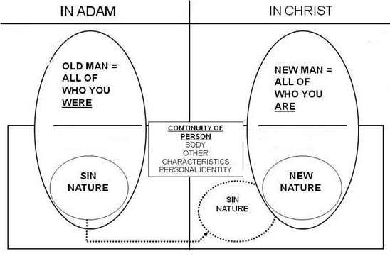

The processes that God is carrying out in the believer – our being sanctified, conformed, transformed, and mature – are all based on who we are in our position. At the point that we believed, by God’s doing we are in Christ Jesus (1 Corinthians 1:30). Our New Man, with a New Nature, is all of who we are in Christ. That New Man, with the New Nature, and a new history, does not need any process of change. The New Man, with a New Nature, and having a new history is as sanctified, conformed, transformed, and mature as ever. There is no variation, nor need for variation. Christ is the ultimate definition of the character God has desired for us. So in order for us to have that character, God accomplished what He desired by placing us in Christ. “In Christ” is the position that God used to ‘pull this off’. In our position we are 100% sanctified, conformed, transformed, and mature. And Christ is the definition of each one of these. In the believer’s position there is no varying nor diminishing of our having been totally sanctified, conformed, transformed, and made mature.

So why is it that we need any ongoing process? Why is there any change in anything at all after we believe? Why isn’t our position in Christ the end of any spiritual changes or variations? Why do we need to learn and know anything at all if our position in Christ does not vary and is already accomplished permanently by God? Why isn’t the Christian life completely free of choices, decisions, understandings, etc. – why aren’t we hardwired to just ‘do the right thing’ out of our changeless eternal God-accomplished position? Hmmm…
Positional person – continuing person

The Old Man is the positional person of the unbeliever - 100% in Adam. The New Man is the positional person of the believer - 100% in Christ. Just as you are in Christ 100% and permanently, since you are a believer, you have 0% (nothing) to do with the Old Adam, the Old Man any longer, and you are never again in any percentage ‘in Adam’, nor can Adam, or the Old Man, the positional person, show up. God’s once for all accomplishments in the believer occurred when He placed the believer in Christ. God does not have anything further to do with ‘your Old Man’, “your Old Adam’. Based on what God has done with the Sin Nature (separated you from it and condemned it), you do have a responsibility to reckon or consider yourself dead to the Sin Nature, and yield your members to God (Romans 6:1-14).

But it is the continuing person that God is in the process of changing:

- Sanctifying (setting apart, as God Himself is set apart and separated)
- Conforming to the image of God’s Son
- Transforming to the image of God’s Son
- Growing toward maturity, with Christ as the definition of maturity.
In these things Christ is the defining Person. If we wish to know what it means to be set apart, it is Christ. If we wish to know what we are being conformed to, it is the image of Christ. If we wish to know what we are being transformed to, it is the image of Christ. If we wish to know the direction toward which we are growing – the definition of maturity – it is Christ. So, if someone wants to define these things in terms of impersonal specifications and outward behaviors, then they have missed God’s intent entirely, and that person is well on the way to stifling legalism.

One way to express the processes that God is carrying out in the life of the believer is that we, in our continuing person, are being separated and set apart, being conformed, being transformed, and growing toward maturity, all of which are already entirely there and accomplished in who we are in Christ, and we are being changed in our continuing person toward the unchanging new history that we have in Christ.

Some questions to ponder
So what if a person doesn’t recognize the difference between position and condition -what will be said of a person who doesn’t live like he or she is saved?

What is the problem with thinking that we or God have any part in addressing the Old Man in the believer – all of who you were in Adam?

What will be the result of trying to change, improve, or build up the Sin Nature?

What will be the result of trying to change ourselves toward being like Christ?

How do we know that God is carrying out these changes in us that God’s word conveys?

These references are from “02 What God is doing in the believer – January 9, 2011 Who were we - Who are we - Who are we becoming - Part I”: H.A. Ironside, Ephesians commentary (page 124), "Some people confound the old man with the old nature. You see, the old man is more than the old nature. The old man is the man of old, what you once were before you were converted. Now you are through with the old man." H.A. Ironside, Romans commentary (page 77), "My old man is not merely my old nature...". Wm. Newell, Romans commentary (page 147), "Also, we must not confuse the “old man” with “the flesh...” Clarifying Ephesians 4:22: These understandings are consistent with Ephesians 4:22 expressing an action that has been taken once we believed (position: “having laid aside the Old Man”), rather than an action that must be taken by the believer continuously (condition: “lay aside the Old Man”). Further, the corruption of the Old Man continues only in the unbeliever. The believer has no Old Man to corrupt. Kenneth Wuest, on Ephesians 4:22 (page 111), “That you have put off once for all with reference to your former manner of life the old man which is being corrupted according to the passionate desires of deceit; moreover, that you are being constantly renewed with reference to the spirit of your mind that you have put on once for all the new man which after God was created in righteousness and holiness of truth.” Harold Hoehner, on Ephesians 4:22, (pages 603, 605, 606), “….accomplished events rather than a process… they have put off or laid aside that old person at conversion…”… “Paul then is teaching, that having been taught in Him, believers have been taught that the old person, according to the former lifestyle was laid aside at the time of their faith in the one who taught them, namely Christ.”…”The present tense denotes continuing action, which indicates that the corruption continues in the unregenerate person.”

