Body building - what is that process?

A common image when we hear the words ‘body building’ is to picture weight training or a chiseled physique. And while our use of the words is not physical, the physical application of these words is somewhat useful in arriving at the spiritual application of the words to the body of Christ – the church. Two primary passages that convey the physical meaning are these:

Ephesians 2:19-22
So then you are no longer strangers and aliens, but you are fellow citizens with the saints, and are of God's household, 20 having been built on the foundation of the apostles and prophets, Christ Jesus Himself being the corner stone, 21 in whom the whole building, being fitted together, is growing into a holy temple in the Lord, 22 in whom you also are being built together into a dwelling of God in the Spirit.

Ephesians 4:11-16
And He gave some as apostles, and some as prophets, and some as evangelists, and some as pastors and teachers, 12 for the equipping of the saints for the work of service, to the building up of the body of Christ; 13 until we all attain to the unity of the faith, and of the knowledge of the Son of God, to a mature man, to the measure of the stature which belongs to the fullness of Christ. 14 As a result, we are no longer to be children, tossed here and there by waves and carried about by every wind of doctrine, by the trickery of men, by craftiness in deceitful scheming; 15 but speaking the truth in love, we are to grow up in all aspects into Him who is the head, even Christ, 16 from whom the whole body, being fitted and held together by what every joint supplies, according to the proper working of each individual part, causes the growth of the body for the building up of itself in love.

Rooted in these passages, and adding others that enhance our understanding and insight, we will proceed on this theme of building up the body of Christ as follows:

Jun No. Passage / Topic

5 23 Body building - what is that process?

12 24 Body building - what is God’s part?

19 25 Body building - what is the believer’s part?

26 26 Where is all this going to end – or will it?

For some months, now, we have been exploring the processes that God is carrying out in the individual believer. But for the month of June we will be looking at what God has done to bring into being the body of Christ, the processes that God is carrying out in and among us in the body of Christ.

The process starts with a position

As a work of the Father, the Son and the Holy Spirit, the body of Christ has been brought into existence, populated by identification, and blessed:

- The Father has blessed us with every spiritual blessing in Christ (Ephesians 1:3).
- The Son’s death., among other spiritual impacts, removed the dividing wall between Gentile & Jew, which is the Law of Moses (Ephesians 2:14-18).
- Believers were placed into the body of Christ by the Holy Spirit (1 Corinthians 12:13).

Each of the above involves principles of identification. The bringing about of the body of Christ, and every aspect of our position in the body of Christ is fixed and unchanging. These are all God’s once-for-all accomplishments regarding the body of Christ.

From position in a Person to process towards a Person

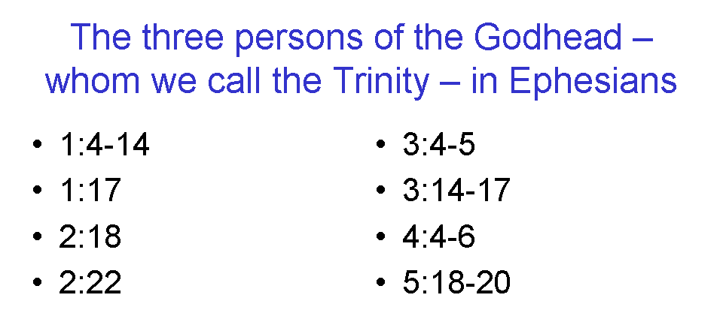
Each Person of the Trinity - Father, Son and Holy Spirit - is involved with the body of Christ. Ephesians, which is a book that carries the body of Christ as a theme (see especially Ephesians 4:12), has the Father, the Son, and the Holy Spirit in close association in the text eight times (see insert). But it is quite evident that the term ‘body of Christ’ focuses on the Person of Christ – we in the body of Christ are His body. He is the head.

So what processes are to be taking place in the body of Christ? Ephesians presents at least these:

- Growing into a holy temple in the Lord (Ephesians 2:21; see also 1 Corinthians 3:16)
- Being fitted and built together (Ephesians 2:21, 22)
- Equipping of the saints for the work of service (Ephesians 4:12)
- Building up of the body of Christ (Ephesians 4:12, 16)

Christ is both the Chief Cornerstone – the basis and orientation of the entire church, starting with the foundation – and the direction and definition of what the Church is being built and growing towards (Ephesians 4:13):

- until we all attain to the unity of the faith, and
- of the knowledge of the Son of God,
- to a mature man,
- to the measure of the stature which belongs to the fullness of Christ.

until we all attain to the unity of the faith

While some will call for Christians or even those of various faiths to unify regardless of belief, that is not the biblical objective. Ephesians 4:13 begins with aiming for the attainment of ‘the unity of the faith”. When Paul wrote to the deeply divided Corinthian church early in his first letter to them, he wrote:

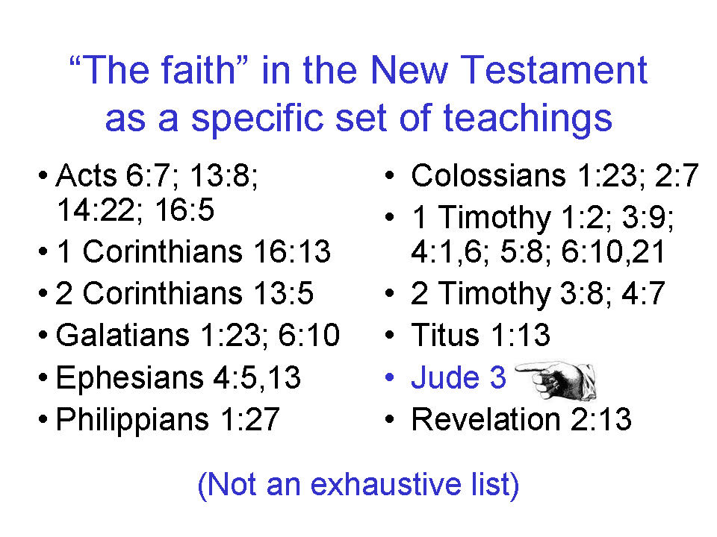
1 Corinthians 1:10
Expanded & Explained

Now I come alongside you as a fellow believer, brethren in Christ, making my appeal to you by the name of our Lord Jesus Christ, so as to have that importance and priority, that you all say the same thing from a unified heart and mind, and that there be no fleshly divisions among all or any of you, but that you all be mended and restored to the unity that you already have in Christ, which comes from the same mind that you have in Christ, and therefore all of you are unified in the same judgment in all things, judging everything biblically, by God’s grace.

The knowledge of the Son of God

There is one Son of God, Who is our Head and our corporate (church body) aim is to know Him:

Philippians 3:7-11
But whatever things were gain to me, those things I have counted as loss for the sake of Christ. 8 More than that, I count all things to be loss in view of the surpassing value of knowing Christ Jesus my Lord, for whom I have suffered the loss of all things, and count them but rubbish so that I may gain Christ, 9 and may be found in Him, not having a righteousness of my own derived from the Law, but that which is through faith in Christ, the righteousness which comes from God on the basis of faith, 10 that I may know Him and the power of His resurrection and the fellowship of His sufferings, being conformed to His death; 11 in order that I may attain to the resurrection from the dead.

The knowledge of the Son of God is not simply to know data about Him, but to know Him personally, in His character (righteousness) and in the history that we share with Him (death and resurrection). Knowing Him helps us understand who we are, since we are in Him, and He is in each one of us who believes.

To a mature man, to the measure of the stature which belongs to the fullness of Christ

The growth toward maturity within the body of Christ is with Christ as the standard of maturity. It is not merely an emulation or superficial copying of Christ’s behaviors, or trying to do what Jesus would do, or an acting job, but a true and deep growth toward maturity of fundamental character as defined by Christ Himself. And while we defined that growth and maturity individually in our study, at this point Paul is referring to corporate (church body) spiritual growth.

And that growth toward maturity is not in some vague or general way or in a way that is necessarily socially recognizable, but is deep and true and spiritual as measured by and expressed by Christ Himself personally – specifically Him.
_____________________________________________________________________________

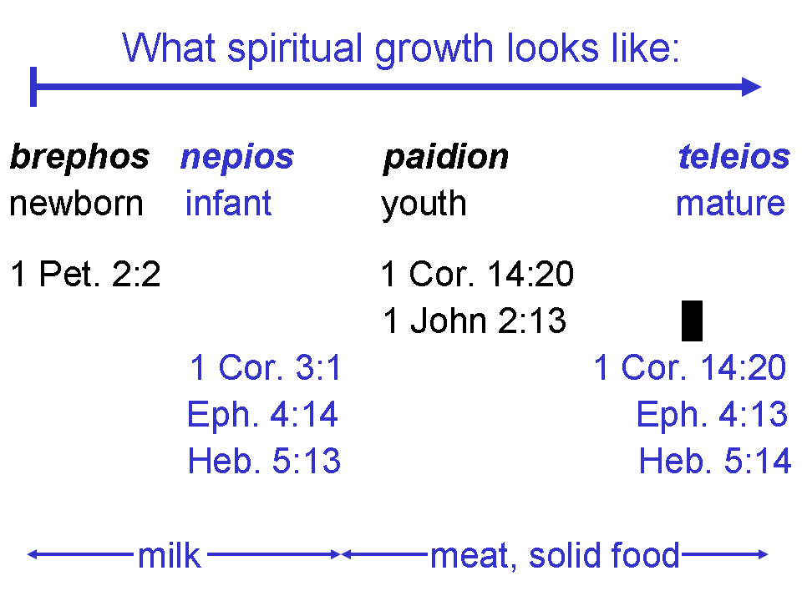

The three groups which make up the peoples of God in eternity: Gentiles, Israel, & the Church:
http://www.hollyhillsbiblechurch.org/materials/the-three-groups-which-make-up-the-people-of-god-in-eternity/ or go to: 1) Materials, 2) The Three Groups Which Make Up The People of God in Eternity. The document is a four page Word (doc) file.

The two primary passages on page 1 are covered in the audio files on the Holly Hills website:

1) www.hollyhillsbiblechurch.org
2) Materials & Audio
3) Archived Files
4) Ephesians & Colossians 2003-2004:

31 God’s Household, Ephesians 2:19 MP3
32 A Dwelling of God, Ephesians 2:20-22 MP3
59 He Gave, Ephesians 4:11-13 MP3
60 Him Who Is The Head, Ephesians 4:14-16 MP3

